Disavantages of statefull:

* Availability issues
* Scalability is a concern : can’t scale horizontally

<https://topdev.vn/blog/stateless-va-stateful-la-gi/>

<https://www.youtube.com/watch?v=nFPzI_Qg3FU>

stateless

level of cache, proxy, https with e-tags

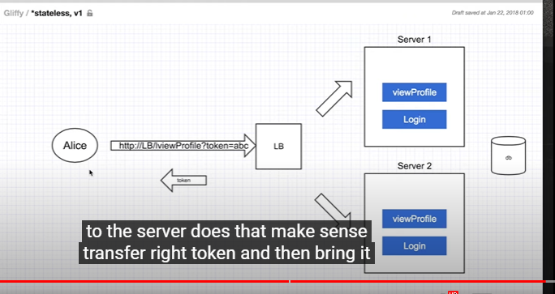

REST API

https://www.youtube.com/watch?v=M3XQ6yEC51Q

REST contraints

* Client/server
* Statelessness
* Cacheability
* Layer Systems
* Uniform interface ( HATEOAS)